MIKE O’RYZA AND THE VEXING VIEW
After visiting Parramatta, my associate Perry Enkema and I journeyed north to the hinterlands of Queensland, to work some cases with an associate, Cal Modulin. We followed his directions to a cabin on a hilltop, and pulled into the driveway. Perry unloaded our diagnostic gear while I reconnoitered the site. I wondered how Cal got us such a great place to work from without any mention of money, but the sound of wheels crunching on the gravel driveway ended that speculation. I half-jogged back around the cabin, eagerly expecting to see Cal’s jeep pulling in, but instead it was a glossy new cobalt blue sedan.
A well-dressed gentleman, Japanese in appearance, slid out of the back seat as his crisply-uniformed driver held the door open. Perry ’s eyes bugged out as he rushed to stuff our ropes into a crate. I tugged the wrinkles out of my field coat and took off my hat as I walked up to meet the gent. “ Michael O’Ryza, at your service.” I greeted him with a soft bow. “We are here to investigate some of the local trees.”
“And I am Suzichi, owner of this property, and I am here to show you the first trees to investigate” the gent bowed quickly, his face betraying tension beneath its placid exterior. “My honored parents will be visiting later this year, and staying in this cabin. Our ancestral home is on the ocean, so they are most accustomed to the calming view of blue water. My motherdelights in wildlife, and the sight of birds large and small. My father is keenly aware of the auras around all plants, and expects our valuable trees to receive the highest standard of care.”
“Your parents sound most wise” I replied. “If there is anything we can do to prepare your property for their arrival, we would be most willing to help.”
“Our problem is vexing, and most perplexing. That is why Mr. Modulin recommended your involvement. Observe the view to the valley below.” I turned to look downward, and saw the problem straight away.
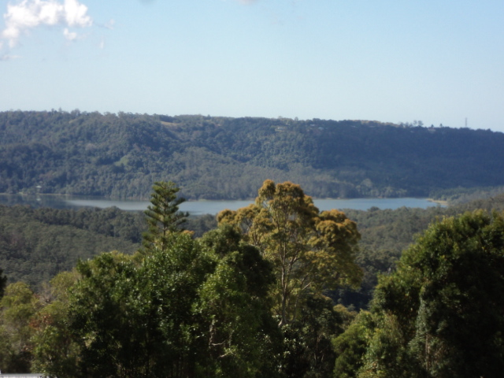

An Araucaria cunninghamii, the hoop pine, thrust its way into our view of the left side of a long lake. To its right, the round crown of a eucalypt obscured the azure surface. “A local tree man, Louie DaLopurre, advocates the historical practice of cutting the trees where a man can easily reach with a chainsaw. They regularly return to repeat the process, as nothing can restrain rampant regrowth in our rainforest region. My father might disapprove, and deny us family funds to purchase adjacent property. If you can find a way to meet my honored parents’ needs, the cabin is yours for the month.”
I nodded agreement. “Since that historical practice evolved, the technology of tree climbing, and tree care, has advanced. We will inspect the trees closely, and give our report to you tomorrow.” Suzichi bowed and slid back into the car. I thought I saw his chauffeur smirk over his shoulder as he drove off, but I paid him no mind. Perry grabbed the gear and we took off down the hill.
“Golly Mike, we’re stuck” he said, shaking his head. “We’re almost out of money, and look at these mature pines over there: they don’t round over into a decurrent form until they reach 20 meters (66 feet) or so. That one blocking the view is young—if it gets cut, it’ll sprout like crazy.”
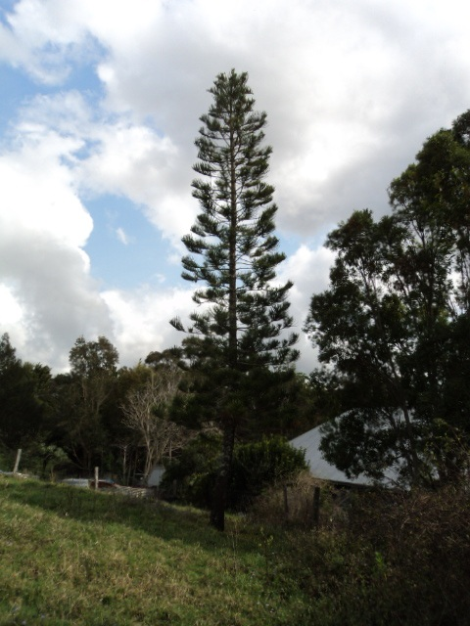
“So it might seem” I replied, studying the regular whorls of branches on the pagoda-like structure. “The distance between whorls decreases with height. I wonder…” We both turned our heads at the sound of a vehicle, and jumped out of the way as Cal’s jeep skidded to a stop.
“G’day, mates!” his voice rang as he hopped out and strode over, pumping Perry’s hand so hard the poor lad grinned with gritted teeth. I got Cal caught up on our assignment as we studied the eucalypt. “Mmm, that is a bit of a tough one” he mused. “Corymbia intermedia, the pink bloodwood, matures at 30 meters (100 feet), and this one’s barely 20. Looks like the left side got hammered in last year’s storms—that doesn’t help anything. The harder they’re lopped , the faster they sprout. Shall I ascend to assess additional clues?”
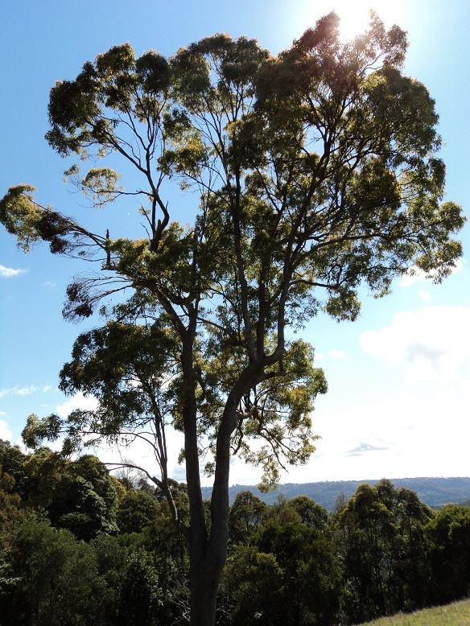
Perry and Cal chatted away as they set their ropes, clinked their carabiners, and ascended. I contemplated the condition of the crown. Multiple upright leaders close together indicated regrowth from old damage. They were at the same height low in the crown, so the older damage was by saw, not by storm. To the left, the broken branches still had leaves attached, a sign that damage was done the previous summer.
I zoomed in with my camera, and saw the strongest sprouts clustered at nodes, near old branch scars. I scanned upward toward Perry’s tie-in point, and saw a bright flash of color. Don’t make any sudden moves, Perry” I called up quietly. “You’ve got visitors—grab your camera.” Perry smoothly unsnapped his shirt pocket, wrapped the camera cord around his wrist, and got off several shots of the rainbow lorikeets.
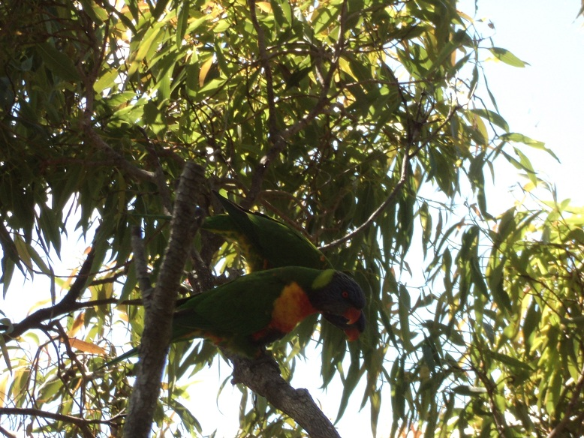
“Ah, they’re lovebirds, they are—typically travel in mated pairs.” Cal called down after the blue-headed duo flew off. “Their body language was like the tree’s: a positive response. One kept bobbing up and down-- probably the male, hoping to get lucky. August is spring, after all.” Both his bare hands wrapped around a branch. “Callus is strongly squeezing long-dead branches to shed them. That Wall 4 shows good resistance to decay. Sprouting response to exposure from that storm damage is at optimal locations for harvesting sunlight. Overall structure seems sound, but no lower laterals on these elongated upright limbs that emerge at the top. There is new growth all around the sunny parts of the crown.”
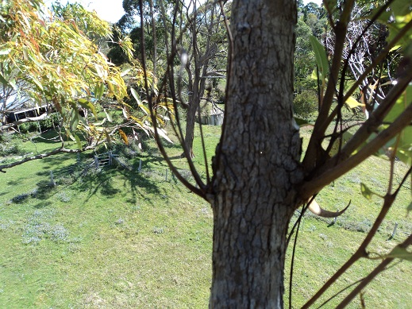 {Below the storm damage, sprouts emerge from buds at nodes, old branch wounds. The interior sprouts to the left withered, dried and died. The sprouts on the right used sunlight to build a buttress at the base of the burgeoning buds.}
“Good job, Cal.” I called up. “Perry, take some panoramic pictures of the property, then let’s wrap it up.” I circled the tree, hunting for hints to help hatch a plan that would earn us a free month’s rent. Visualizing the lorikeet bobbing up and down, I realized the bird knew the answer before I did.
What did their feathered friend tell our team? Turn to page gazillionty-eleven
******************************************************************
Cal put another prawn on the barbie while I leaned back and made notes on my clipboard, savoring the last of the apple-cashew curry. “Well, I guess I’ll go pack the car and get ready for camping” Perry moaned, glumly picking up dishes. “No way those trees can be shortened enough for view, and comply with standards too. Both Australian or American standards prohibit topping, clear and simple.”
“Yeah it’s a tough one, mate” Cal agreed, turning over the sizzling seafood. “How are we going to get another night here, let alone a month?”
”No worries, no dramas--it’s all right here” I said, tossing the clipboard on the table and pouring another round of the local grape drink. The AS4373 Pruning Standard slid to the floor so I picked it up, and shook it for emphasis. “Don’t leave home without it, lads. When in doubt, read the standards. Study the trees, and study the birds.”
Perry slid my glass away. “Errr, that’s enough for now, Mike. I’m gonna see what we have for dessert.”
“The Corymbia did have a lot to say” Cal mused, poking the prawn with his skewer. “The storm did not tear out those upright limbs from the lopping cuts at their attachments. They broke at “hot spots” where they narrowed in diameter--not at the elbow, but where the “muscles” taper, toward the wrist. The old epicormic sprouts did not fail completely—as they built buttresses, they became “endocormic”, anchored to the core.”
“Excellent observations, mate!” I rocked my chair forward and checked off one paragraph, tapping my foot to a young Michael Jackson singing “Rockin’ Robin” on the oldies station. “And what did that lorikeet tell you as he kept a-hoppin’ and a-bobbin’ and a-singin’ his song?”
“Crikey, that’s it!” Cal cried, stabbing the poor prawn over and over as his mental wheels chugged and churned. “Those limbs just need endweight reduced. Higher climbing and smaller cuts will get it done right. By pruning in rhythm with the tree’s growth, the height can go up and down while the tree system stays in balance, just like that bird bobbing while balancing on that little branch. Restoration pruning after the sprouting slows develops taper, and lower laterals to make the next cuts back to. The crown morphs from excurrent to decurrent.
When a leader is reduced, upright laterals can develop into leaders. Other, more horizontal branches send up reiterations, new tips into the light. So a more or less excurrent part of a crown will become more decurrent, its vigor is distributed to several nodes, which grow more gradually than a single leader. It’s like the old fashioned way of training a fruit tree; small cuts causing maturity ahead of time.”
I checked the next item, and started to stand. “So our specifications result in healthy growth and longevity. We are ready for the client.”
“Not so fast, Dendro.” Perry clamped his hand on my shoulder and rocked me back to earth. “How can that poor pine tree be sustainably shortened? Single-stemmed species do not have all those growing points to develop a lower crown. Look at 6.1.7: ‘Topping…shall be considered unacceptable’ How can a central leader be sustainably managed, if it is shortened for view?”
“Oh, I forgot that you were not on that job with the Pinus strobus at the hills back home.” I gently replied, reaching for a refill. “Pruning is not topping, if done to nodes and with regard to health and structure. The answer can be found in larger birds, my physique after a hearty meal, and my headgear” I exclaimed, letting my belt out a notch, donning my akubra hat with the bright green ribbon, and trimming its brim with a firm stroke of my thumb and forefinger.
Codit pushed the cork deep into the bottle and shuffled off with it, muttering “That’s it. I’m going, to enjoy the one night I get to sleep in a bed.”
“Not at all, dear lad” Cal leaped up and started striding like a Western martial artist, the standard in one hand and skewer in the other. “You saw those excurrent Araucaria nearby going decurrent at maturity. Perhaps controlled pruning can even “veteranize” a pine by initiating that process before its time. 4.58: ‘Pruning to enhance a specific view without jeopardizing he health of the tree.’ By carefully shifting apical dominance with the smallest cut possible, the tree will spread more leaders in good health, like Michael here.“
I clasped my hands around my belly and smiled. This chap was a little rough around the edges, but he had potential.
“Big birds and hats—clues to cut the branches off the severed top of the tree, and weave them together in a sort of platform.” Cal continued, slashing his skewer like a sword and a needle, simultaneously slicing and sewing. “The shade and physical obstruction from this ‘cap’ will stop sunscald and sprouting. When the stem is reduced, the auxin hormones enforcing apical dominance will be produced at many reiterations. More growth points are supplied with water and nutrients from the stem tissues, resulting slower growth for each single leader.”
I finished writing as Cal thrust his skewer toward Perry so suddenly that he almost lost his grip on the bottle. “That’s it then, team!” I stood up. “Our client’s objectives are a view of the blue, habitat for birds, and standard arboricultural practice. Work that is done according to our specifications will accomplish those objectives, and earn us a month’s rent.”
Araucaria cunninghamii Pruning Objectives:
Health by reducing stem and advancing transition to decurrent form.
View improvement by opening sightline from cabin to lake
Increase habitat by creating a potential nest or perch for large birds
Pruning Methods and Specifications:
Reduce with one ~10 cm cut just above the 8th whorl (node) from the tip. Remove lateral branches from cut portion and weave them together above the stem, into the form of a nest. Ecourage occupation by avian associates, to inhibit cracking, decay and sprouting.
.
Over time, remove or reduce vigorous sprouts and let the outer branches reiterate new growth and droop downward under their own weight. Repeat this work every 3 – 5 years or as needed

Corymbia intermedia Pruning Objectives:
Reduce risk of tree damage due to future storms
Manage Health by speeding wound closure to lessen decay should be explained (e.g. keep some new shoots adjacent to the wound)
Restore Structure by reducing regrowth from old topping cuts and advancing other laterals.
Improve view by opening sightline from cabin to lake
Pruning Methods and Specifications:
Reduce upright branches at top of crown 1-3 meters, using 3-6 cm cuts made to laterals, forks, or buds, until ? crown is 1 meter below sightline from cabin to lake.
Remove all dead branches and stubs facing upward 3cm or greater throughout the crown. Retain dead branches facing outward from the crown outline.
That should not be enough. The crown should be led into a decurrent architecture.

When we presented the specs to our client the next morning, I saw the tension fade from his forehead. He was so pleased with the plan that he hired Cal and Perry to carry it out immediately, and invited us to dinner with him that night.
“Gentlemen, after inspecting your work, I believe my parents will be delighted with the view, the birds, and the trees. My father can observe gradual and manageable regrowth. My mother will delight in watching for those lovely lorikeets to move in and raise a family, and for raptors to rest on the platform on the pine.”
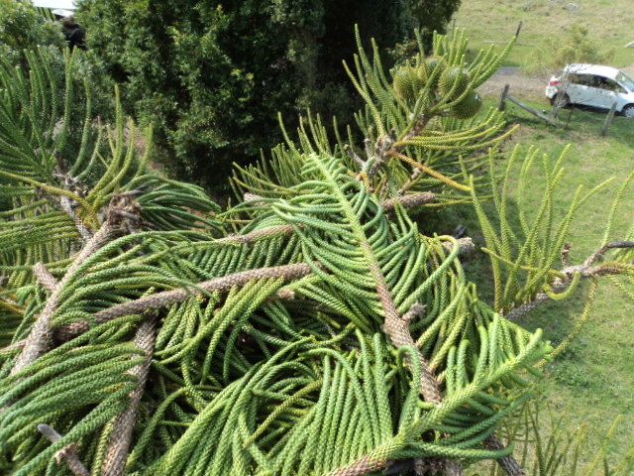)
This is great, I thought. We were “home free”.
“However, I have noted one problem” he added. “Standards require the removal of all cut branches, but your plan calls them for them to stay.”
I pulled out the A300 Pruning Standard, and checked the “shall” at 5.3.9. He was right. Perry’s face fell, but Cal pulled out the AS4373 and read, “5.6 Hanging branches: All hanging branches shall be removed from the crown’ We inserted those cut branches into forks, so none was left hanging.”

“Very well” Suzichi held up his hand. “ The cabin is yours, and we will want more arboricultural work on our properties. I toast your success” he said, raising his glass.
“Here’s to pollarding for parrots” Perry and Cal clinked their cups as they bobbed their heads up and down.

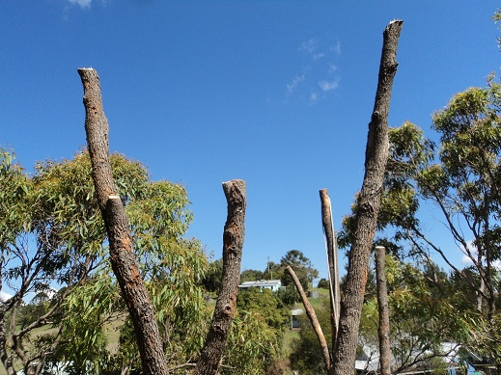

The six highest uprights were reduced to forks or buds, with 3-6 cm cuts. The cabin is visible at the top of the hill. Pruning is done in early spring, so prompt sprouting is expected. Restoration cuts will be made when sprouting slows, forecast to be in 3-5 years

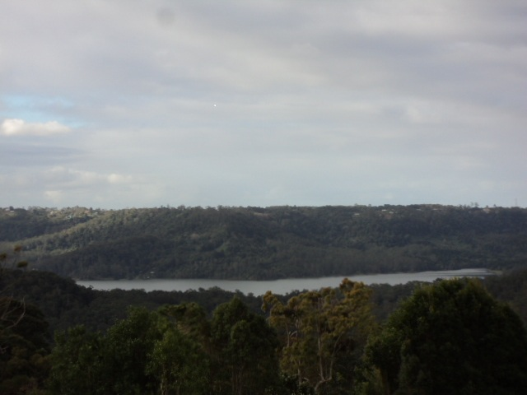
The pruned trees have some room to grow before being pruned again.

