
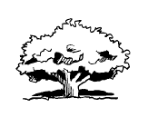 Better Tree Care Associates
BETTER
www.bettertreecare.com

P.O. Box 1287, Apex NC 27502
(919) 387-7045
Tree Care

Email: info@bettertreecare.com
Associates

Kvill Oak Report 140610

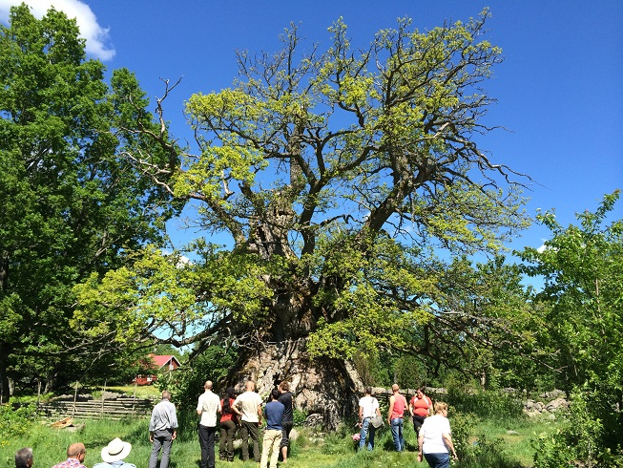

HISTORY AND BACKGROUND

The Kvill Oak has historically been surrounded by pature. According to the drawing on the entrance sign by N. Forshed (1984), the tree had a full, round crown 30 years ago.
2013 the steel band removed and replaced, and there was a drought.
June 9 2014 an arborist who participated in that 2013 work recalled that it also included deadwood removal and foliar fertilization including magnesium. Other anecdotal information is in Appendix X.

OBSERVATIONS
June 8 2014 Much of the crown is dead. Some of the twigs have buds on them, indicating that they died recently. The remaining portions of living crown have sparse foliage. The leaves are yellow and small. Dense grass and other plants grow thickly around base. Rocks are piled around base. Two columns of living tissue look more vital than the rest of the trunk.
- Tall grass and aggressive weeds are growing against the stem. The grass has a heavy thatch buildup, and rhizomes are growing 10 cm or more below the surface. Tree roots are present in the soil below the grass roots. The soil around the tree roots is dry compared to the soil above. The roots of the other plants are growing deeper than that, between the rocks piled around the trunk. Many of these other plants have resprouted vigorously after being coppiced, cut back in the past.
- The bare soil of the footpath has no roots near the surface. Oak roots are visible, but not numerous, starting at 10 cm deep or so. The soil on the path is compacted, more difficult to excavate using a twig than bare patches of soil further away from the stem.
- An iron strap was replaced with a steel cable held away from the stem by 10 cm or so by eyebolts drilled into the trunk at approximately the same level, 3 meters or so above grade. 9 bolts ~1 cm diameter are visible from the south side, there are perhaps 13 in all in the trunk. I tried to scrape off the black bark in the grooves left by the strap with a small knife. Unlike adjacent bark, this compacted bark is impervious to such probing.
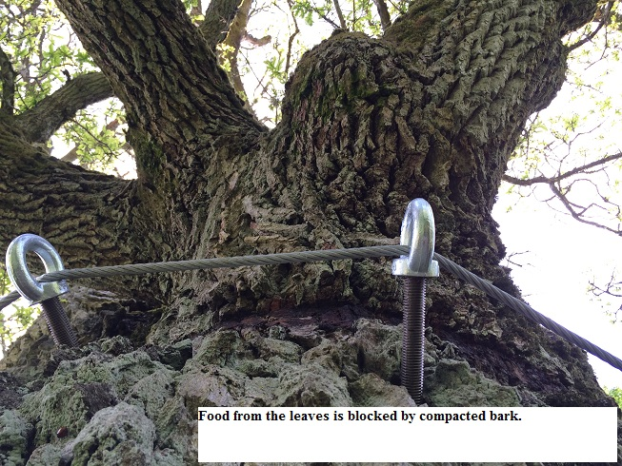

- A dead section of the trunk on the north side has pulled away but is secured from failing further by a separate section of of the same type of cable and fasteners.
- The vertical trunk sections (segments, columns) that connect to the most vital portions of the crown have the deepest grooves from the iron strap. These columns also have living tissue inside the cavity, as indicated by scratching the bark in two places (east and west). The material on the floor of the cavity is rich in organic material, but poor in minerals.

DISCUSSION
- Research recently presented in Italy has shown great success in developing an adventitious, secondary root system in a veteran tree by replacing soil around the trunk. See Appendix A.
- Soil compaction limits root growth by limiting pore space for the needed amounts of air, water and bioactivity.
- The strap prevented the natural flow of nutrients. These are the tissues that were conducting the most sap. The compacted bark is continuing that compression and dysfunction, even without the strap. After similar obstructions were removed in other trees, the descending photosynthates caused a bulge that lapped over the constricted areas. If the dead compacted bark is not removed, these areas tend not to expand, even after several years.
- Like leaves, dead branches and trunk sections recycle nutrients back to the tree. Using dead sections of wood would have a double benefit: people’s weight would wiggle the wood, pressing it slightly into the earth. This increased wood-soil contact would accelerate the formation of mycorrhizae and the breakdown of woody tissue and the release of nutrients to the soil and roots.*
- Adventitious rooting might increase if the material adjacent to the living tissue inside the cavity was amended.

SPECIFICATIONS

- Remove some of the existing humus inside the cavity near the living segments. Save this for blending into the soil outside the base. Blend in soil harvested from nearby healthy oaks 1:1.
- Starting at the stem, remove loose rocks and pull weeds—grasses and aggressive non-symbionts—out by the roots as much as possible. Chop the rest low and remove all of the arisings (debris). Leave flowers, herbs and forbs that are not extremely competitive and are identified as symbiotic for nectar etc. Cover areas thus exposed to prevent drying.
- Into these newly opened areas, add a blend of humus from inside the cavity and soil harvested from nearby healthy oaks. Cover with 5cm aged oak mulch; woodchip/leaf mix.
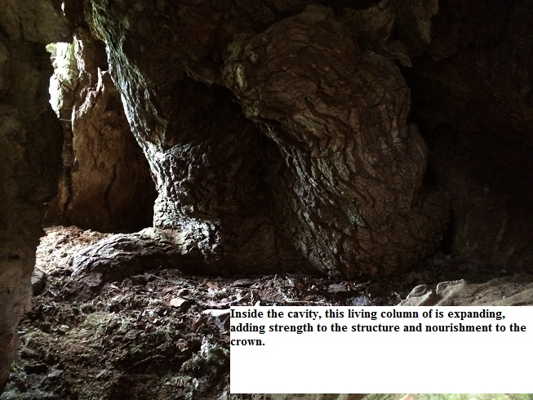

- Aerate soil on pathway 10 cm deep with 1-1.5 cm holes.
- Smother grass that is not pulled out with newspaper 3 plus layers and 5cm aged oak mulch; woodchip/leaf mix.
- Uncable broken dead stem section. Split along grain and trim to make sections lay flat enough to be used as planks for walking. Lay stem sections over the current path as a natural boardwalk.
- Consider planting shallow-rooted natural associates: Rosa sp., Vaccinium sp., and other species with less aggressive root systems, in strategic areas off the path to discourage foot traffic.
- Bend the ends of the remaining iron strap away from the tree as much as possible, without damaging tree tissue.
- Using a clean sharp chisel, scrape off the dead bark that was compacted by the iron strap. Remove compacted bark down to the inner bark.

*Observation by Arborist Dan Crawford

This concudes my report. I am available to clarify any details and figures within it.

Sincerely Yours,

Guy Meilleur, ISA Board-Certified Master Arborist #SO-0284
Certified Municipal and Utility Arborist and Tree Worker
Better Tree Care Associates
PO Box 1287, Apex NC 27502
919-387-7045
Appendix A: From the Italian Arb Society, May 28, 2014 This presentation (title and author not in program) was on root growth on a veteran tree after soil replacement around the base.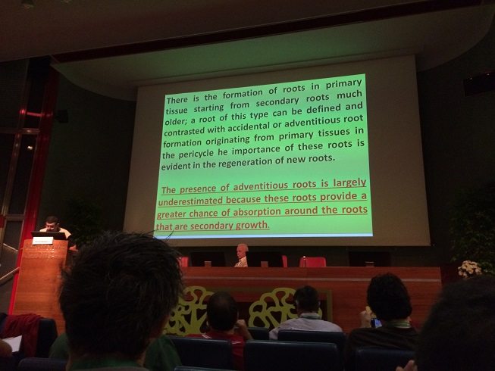 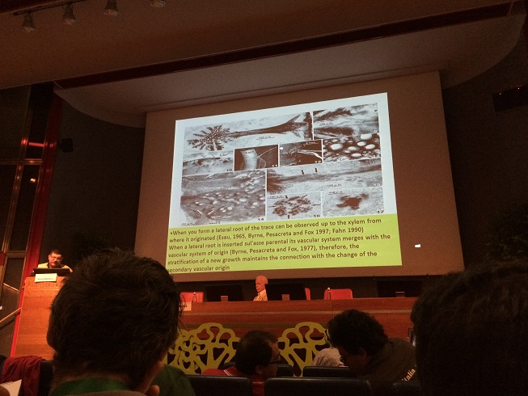

Supporting studies cited here. This presentation was excellent, the research appeared to be well substantiated and peer-reviewed. I attach these slides here in advance of more identifying information, which is actively being sought.
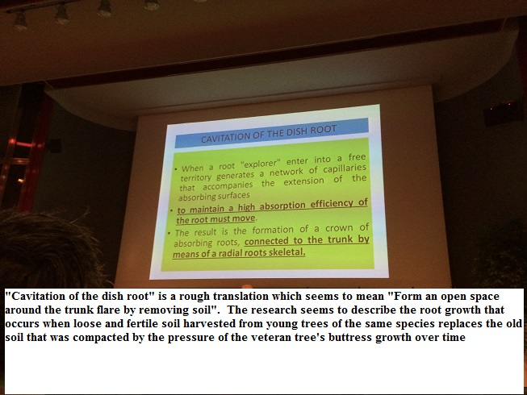
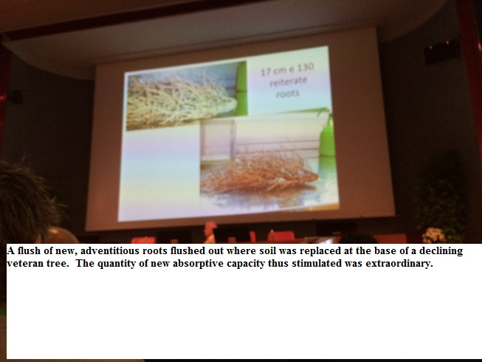
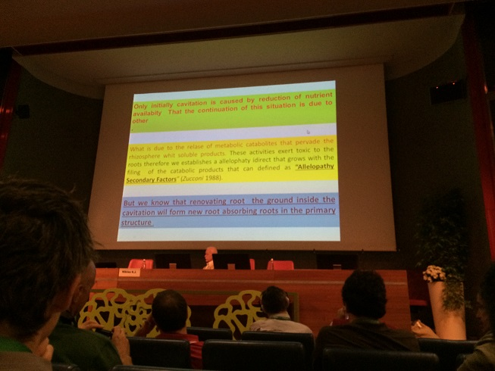
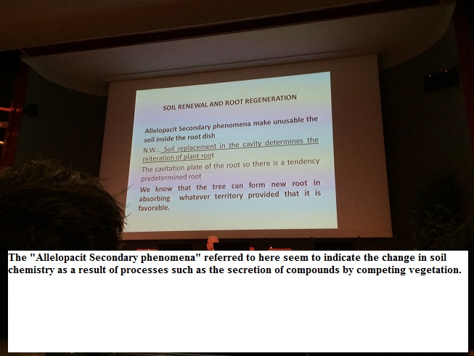

APPENDIX B from the International Oak Society

The Mighty Oak of Kvill
By Stefan Foconi | May 13, 2014
Dendrology
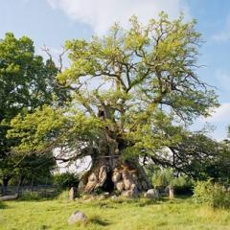
[A version of this article was originally published in International Oaks No. 20 in 2009.]
After an excessive traditional dinner on various forms of eel, down on the southeastern coast of Skåne, and a long breakfast the following morning, my brother and I enter the car that will bring us back towards the north and the area around Vimmerby, a region in the province of Småland that is today well known for two things: Astrid Lindgren, the author of children’s books, and the mighty Oak of Kvill—the Rumskulla Oak, as it is also called.
The pressure is high and the sky clear, and my brother, who’s behind the wheel, insists on driving all the way with the roof down, even though nobody else does so in mid-October. At least we're suitably dressed and wearing woolen caps.
I go through my questions again. When we arrive at a junction, just before the oak, the expert on forestry Thorsten Ungsäter, in his capacity as local connoisseur has had the kindness to meet us and answer some of my questions. I have never before seen the oak, only through the years imagined what it would be like. I am now referring to the oldest organism of Sweden, in addition the oak with the widest girth in the whole of Europe, measuring at chest height not less than 14.11 meters!
The experts estimate the age of this oak to be roughly one thousand years. There are older ones abroad, according to various sources, but if there are oaks outside of Europe with an even wider circumference than the giant I am just about to meet I do not know. Anyhow: in Europe it is exceptional, and for more than one reason, as I will soon try to explain.
Thanks to the Gulf Stream there are no oaks worldwide growing further north than in Scandinavia. There are two indigenous species in Sweden, Quercus robur and Q. petraea, as well as hybrids between the two. Approximately one percent of the wooden area consists of oak, a high figure for a country that by European standards is fairly large and of which 55 percent is covered by forest. Q. robur grows in fertile clay soil with good access to water, while Q. petraea prefers drier and more stony grounds. The northern border of Q. robur is traditionally put at the river Dalälven, situated on the 60th parallel (today it even goes further north), but in Norway it reaches all the way along the coast up to Trondheim. In plantation there is a mature Q. robur thriving up in Haparanda, almost on the 66th parallel, proof of the extreme adaptability of a species that is tropical in origin. During the warmest period after the last glacial period, about 6,000 years ago, the oak (like all other broad-leaved trees) penetrated much further northwards.
The Oak of Kvill is a Q. robur, though its appearance today is as far away from the pollarded, emblematic oak as you might possibly get, a lot more original and certainly more marked by age; in a word, unique.
When we reach the settled meeting point, after a rather windy drive, I change to Thorsten Ungsäter's car, so that I can use the slow final route on dirt roads for immediate interrogation.
From a dendrological point of view the area around Vimmerby is rather amazing, since within the radius of 10 kilometers you could spot not only the mightiest oak of Europe, but also the thickest birch, apple tree, maple and hazel of Sweden, plus the second thickest lime (linden). The rural district of Rumskulla is also brimful of interesting natural phenomena like faults, erratic blocks and giant’s kettles.
The Oak of Kvill got its name after the pasture where it happens to grow, called Northern Kvill, an ex-lieutenants house; it is also known as the Oak of Rumskulla, since it is in the parish of Rumskulla, situated in the county of Kalmar. The name Rumskulla is derived from the older form Romfarakulla (meaning literally: Rome + travel + hill), as this district was a stopover and a resting place for pilgrims that were off for Rome. The prefix ”kvill” is connected to the verb ”kvillra”, onomatopoeia for the gentle sound of water in motion, hardly surprising given the vicinity of the small river Stångån. According to local oral tradition the tree is called the Oak of Christ, because it was said to have sprouted from an acorn that fell at the time of the birth of Christ. The oak has been placed under protection since 1928, but was regarded as worth preserving already in 1905, when six stones were placed around the trunk. Detailed accounts from the 18th century tell us that the trunk was already hollow at the base by then, a condition caused by the obligatory invasive fungi, and perhaps further aggravated by the farmer’s habit of lighting fires of branches and miscellaneous rubbish at the foot of oaks. This is information I’ve picked up from reading and listening to Thorsten, but now it’s time to get out of the cars and finally have a look at the tree in real life!
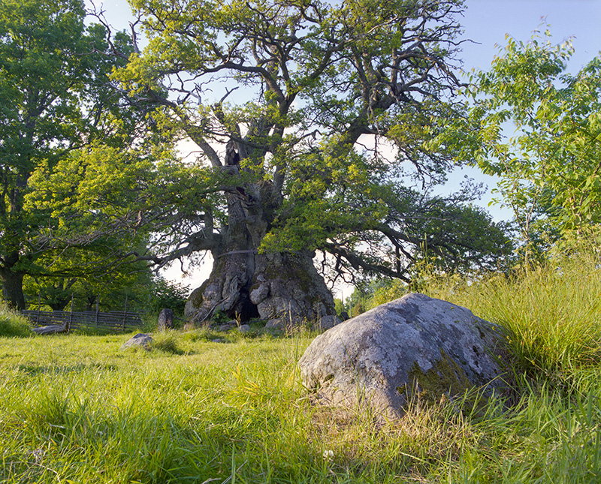
The Oak of Kvill. Photo: © Gustaf Emanuelsson.
From the parking lot a narrow trail leads to the giant. We are not alone. Some German tourists – the area is rather popular with Danish, German and Dutch cabin owners – have also found their way over here. Approximately 50,000 persons visit each year. The first impression is the current shortness of the oak. We estimate its hieght to be 12 or 13 meters. The oak of Kvill has obviously once been much more statuesque, but already during the severe winter of 1708-09 the crown was reported to have withered away and since that time the oak has crouched down considerably more. It is also already lacking leaves.
Deciduous oaks are no doubt renowned for holding on to their leaves well into the winter, in the case of Q. petraea even until the emergence of the following season’s leaves, but the Oak of Kvill is now the only oak in the domain that has already gotten rid of its leaves (as well as of the acorns that it still produces in large quantities during masts) although it’s only the 18th of October today and the autumn has been mild.
We approach further. The next thing that is striking about the Oak of Kvill is the furrows and ridges of the trunk, or rather the enormous crusty, coarse cracks in the rugged bark. It looks almost as if lava had suddenly erupted from a volcano, then had long ago stiffened into ash-grey tuff. Due to the hollowing out of the center the rest of the trunk is more like a thick skin. Before protection, this cavity was used by the farmers as a toolshed. The opening through the trunk runs straight in a north-south direction.
How could it live for so long? Why wasn’t it cut down for timber? How can a protected tree be allowed to wear two pretty sharp and non-elastic bands of metal around it; these are some of my most haunting questions, along with the following one: how could the Oak of Kvill grow that big when it stands in such poor soil?
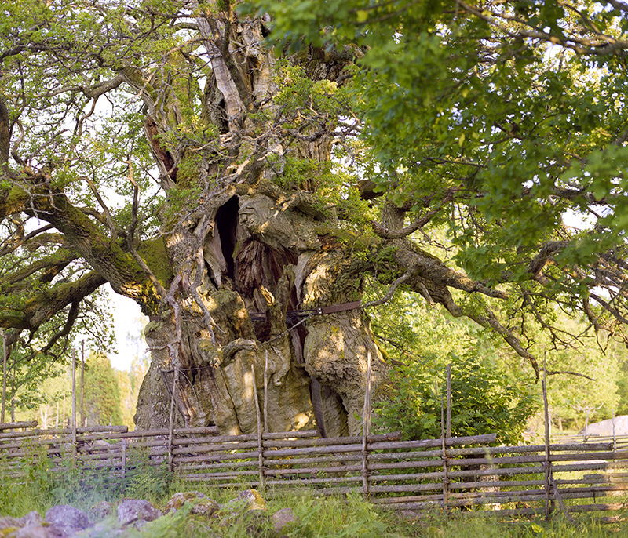
The side of the oak requiring support. © Gustaf Emanuelsson.
The grounds surrounding us is pastoral, with plenty of browsing cows, typically for the province of Småland full of boulders and with a shallow layer of mould. The most characteristic tree in this biotope is the juniper (Juniperus communis). It completely dominates the landscape no matter what direction you’re looking in. For the time being the Oak of Kvill receives undeserved competition for nutrition and more importantly light from a mere 60- to 70-year-old offspring that has been allowed to grow up only some 10 meterstowards the northwest. Thorsten and I agree that this ”suckling” should be removed immediately, in order not to further put stress on the giant. Oaks as old as the one at Kvill not only need a maximum amount of light, but also free entrance for the wind, so that fungi specializing in attacking rotten wood are not activated.
I step over the iron chain that surrounds the tree at ground level and place myself in the midst of what was once the very center of the trunk. Green moss is plentiful, like some kind of belt made of velvet, reaching from my waist up to about 3 meters high. The same part of the interior wood is in many places full of circular holes, drilled by bugs, with a diameter of one millimeter. It is the abundant quantity of bitter tannins in the wood, as well as in the leaves, that in the shorter perspective makes both less than tasty for many vermin. In combination with the deep tap root these are the factors making the longevity of oaks at all possible, but this doesn’t hinder older trees from attracting hordes of parasites, not least the fungi that thrive on decomposing wood, particularly the oldest parts in the centre. The brownish-black mass that is formed, the mulm, is the home of innumerable insects that live off the fungi. Many birds in their turn eat the insects that are specially adapted to oaks. It is in various cavities in the tree that the mulm is created, consisting of sawdust-like residuum from gnawing, manure, dead animals, bird nests etc.
When I step out from the interior my head is full of thoughts about what the oak might have experienced in terms of changes during its enormous life span. Not that trees are able to think, but in its late capacity as tree champion this oak must have been exposed to a whole lot of extra attention from humans. It has for example appeared in many documentaries on television, as well as featured in a movie that was quite famous in the late 60s, not the least because of its sex scenes, called I Am Curious (Yellow), by Vilgot Sjöman. The reason behind the choice of the Oak of Kvill for erotic exercises might stem from the fact that the director happened to have been raised in the area. Whatever one thinks of film director Sjöman’s taste when it comes to connecting such an explicit scene with the famous oak, it is nevertheless fairly innocent in comparison with all the human sacrifices and hangings that mankind has so often willingly used thick oak branches for.
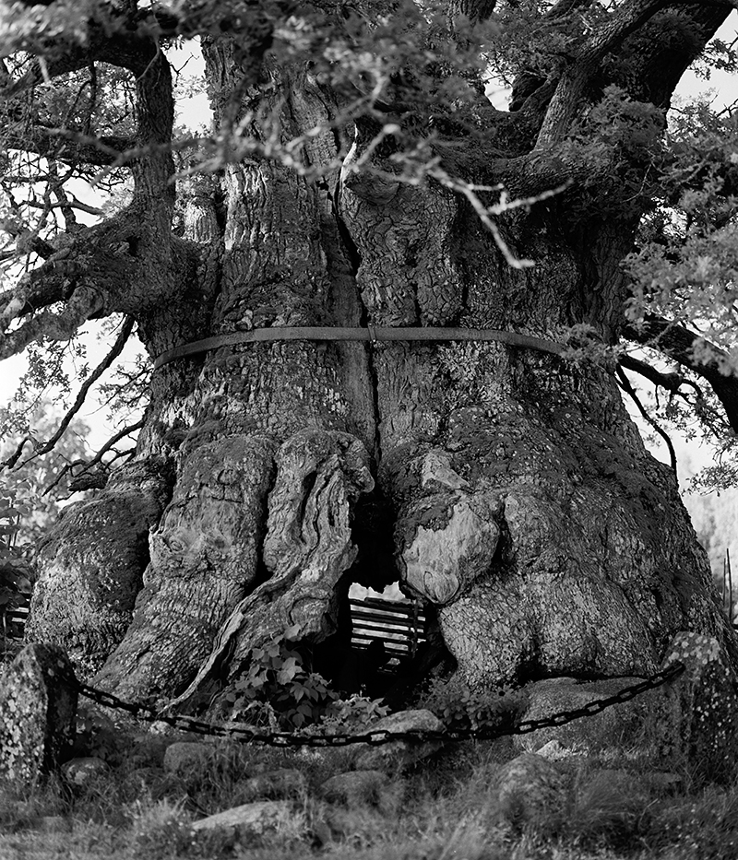
The metal band and the passage through the hollow trunk. Photo: © Gustaf Emanuelsson.
The number of species that directly or indirectly depend on old oaks for their existence is mind-boggling. It’s one thing that tropical trees in a rain forest are the hosts of very large numbers of individual species, not yet identified by scientists, but here in a rather poor – from the perspective of biodiversity – corner of northern Europe, Q. robur, considered as a biotope, is completely in a class of its own. Fifty years ago scientists thought that 500 species of insects, fungi, moss and lichen might be living off the oak, and later upgraded this figure to something like 1,000; nowadays many experts regard the figure of 1,500 as more likely, most of these not existing anywhere else, birds and bats not included. One should keep in mind that the complete flora and fauna of a country like Sweden contains not more than circa 50,000 species in all. From an ecological point of view it is important that the distance between old oaks is not too far, since the parasitical species existing on these long-lived and hence relatively stable creatures are for that very reason not adapted to a life of motion. It is the sheer volume and age of mature and ageing oaks that create the multiplicity of micro-environments. We are now talking about dead wood in various phases of decomposition, the living wood, the roots, the crown with its leaves and acorns, the sunny side of the trunk with its innumerable crannies and cracks as well as the shady side, with a considerably cooler climate, plus dry fallen branches that should be allowed to remain on the ground withering away. Each of these niches is home to separate species.
When it comes to the iron bands around the Oak of Kvill, the first was put on as late as 60 years ago by a blacksmith called Fransson, on request from local authorities. A generation later, in 1992 to be precise, this was supplemented with another band, higher up on the trunk, this one added by the son and grandson of the first smith. Standing by the oak today it is easy to observe that the bands are cutting into a still growing tree. Back in 1913, for example, the circumference was ”only” 12.75 meters, as opposed to today’s 14.11 meters, implying that the Oak of Kvill continues to expand at an average pace of more than 1.3 centimeters each year, obviously only from the exterior, which is precisely the layer that is affected by the iron bands.
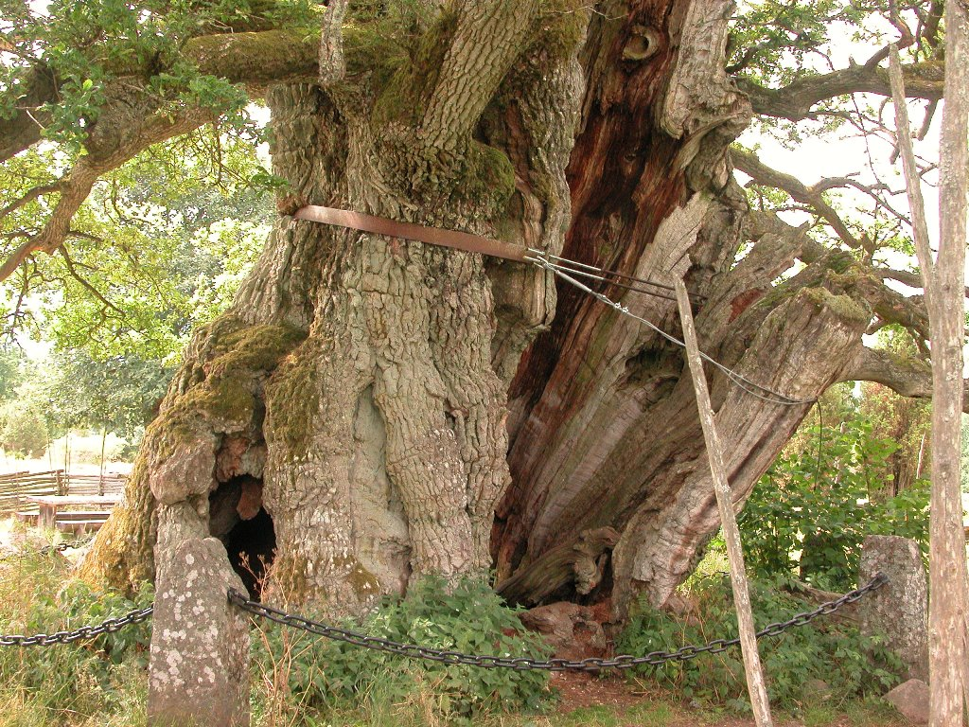
The lower metal band and the wire attached to it is what holds the oak together. Photo: © Maarten Windemuller
These bands are already in the process of being walled over by the oak. In fact they were removed in an attack in 2002, by a confused person that thought he was doing the tree a service, only immediately to be put back again. However, as my cicerone puts it, today it is already too late to remove the bands, since especially the lower one, with an iron wire attached to it, is what – strangling or not – holds the oak together. Without support the Kvill Oak would hardly be able to stand on its own any more, since the part of the trunk facing south would then fall out and possibly drag the rest of the tree along with itself in the fall. As long as this is not happening the oak should be able to get by for another century, especially given the fact that it looks considerably healthier today than it did after the severe drought in 1959, when it was about to give in. The hurricane Gudrun, which in January 2005 turned over hundreds of millions of trees all over north western Europe – in the southern part of Sweden alone 75 million square meters of forest, the same quantity as the total take of three years of ordinary industrial activity – didn’t affect the giant at all, even though mature oaks are somewhat vulnerable to wind.
How could the Oak of Kvill grow so large, given that the hunger for boards of oak for the use of the navy was insatiable and continued for centuries? First of all, the Oak of Kvill happened to start growing on a less than optimal spot. This was not where people were looking for large oaks. Secondly, it has had good access to water, even though it has in all likelihood been browsed by cattle; but on the other hand for the same reason probably during its entire life it has been protected from the woods growing too close. It is surrounded by big stones, which might mean that it sprouted on a spot that animals found difficult to get at, on top of it being surrounded by junipers, something that should have increased the possibilities for the tree in its youth to be spared the axe and the muzzle.
The oaks of Sweden were the property of the state and because of this loathed by the peasants, who didn’t have much to gain from having oaks on their land, and consequently in secrecy tried to get rid of small oaks as soon as they appeared, in marked contrast to the aristocracy’s need to adorn their parks with as many mighty oaks as possible, at the expense of other trees. For the peasants, oaks were simply associated with nobility and the authoritarian repression of the state. An edict concerning the preservation of oaks was put forward already in 1347 and included in the national law of King Magnus Eriksson. These restrictions were further enhanced by King Gustav Vasa in 1558, only to be accentuated even further during the era of Sweden as a great power, when it was directly called for to actively plant oaks. As from 1746, the oaks were owned by the state, even if they grew on the private land of individual farmers, and since the farmers needed boards of oak themselves for larger constructions, most probably many trees were chopped down outside the villages, a crime that was severely punished and in itself made the oak even more hated, especially since the ones that grew out in the pastures and on the meadows diminished the output of crop by casting shadow and absorbing nutrition, not to mention that they also embittered the soil with leaves that take their time to decompose. It wasn’t until 1830 that peasants could buy the oaks growing on their own grounds. The state’s restrictions didn’t end until 1875, with the exception of the land owned by the church, which the authorities kept control over well into the 20th century. For the majority of the population the advantages of growing oaks were – at least legally – solely the use of acorns as food for pigs (and during famines for the humans too, for sure), the tannins in the bark for the preparation of leather, the production of various medical treatments and for the making of ink.
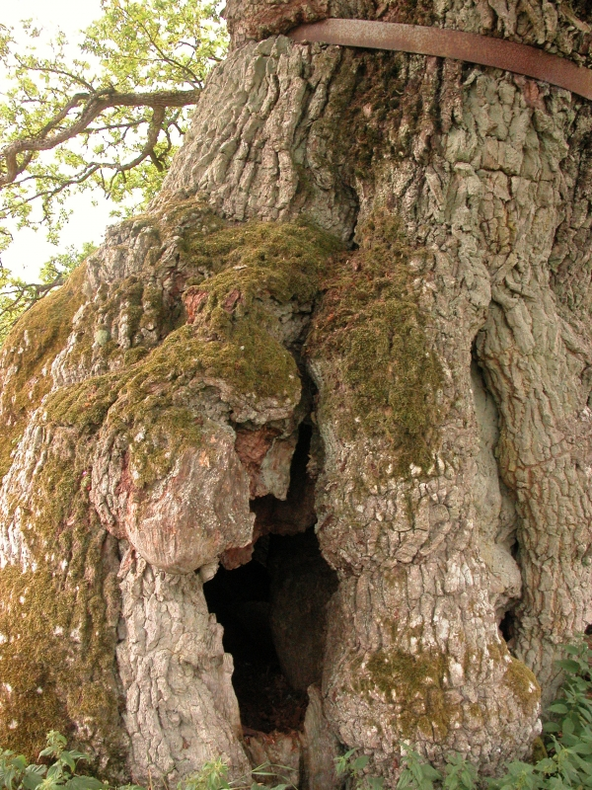
The metal band is already in the process of being walled over the oak.
Photo: © Maarten Windemuller
Oaks have more often than other trees been in demand for the construction of warships. In order to build a large flagship in the 17th century about 2,000 mature oaks was utilized. On top of this, the erection of castles and churches swallowed enormous amounts of larger oaks, preferably cut down when they had reached the age of 150 years, with a diameter of 75 centimeters. It might be difficult for somebody living today to fully understand the amount of large oaks that were used. According to the Ministry of Forestry there are today approximately 14,000 oaks in Sweden with a circumference above 4 meters, mostly in the provinces along the Baltic Sea. This is a low figure – and one that is going to diminish even further – compared to what it was in the old days. During the 18th century the navy counted that within one single parish there would be 38,500 oaks to be eventually cut down, and this did not include the oaks belonging to the church and aristocracy, which, being excluded from the state monopoly, were not counted. As soon as the monopoly on oaks was terminated, the amount of larger oaks continued to dwindle, since the individual peasant gladly got rid of the trees that were standing in his fields and competing with the crop for light and water. This tendency is continuing today. The elderly giants have fewer and fewer successors.
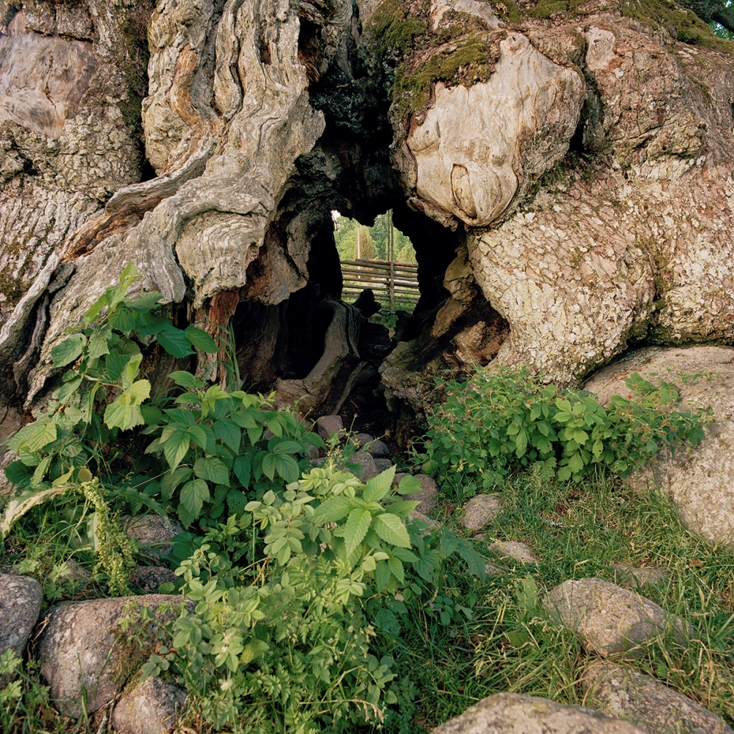
A view through the Oak of Kvill.
Photo: © Gustaf Emanuelsson
Since the Oak of Kvill is pretty much the same age as Christianity in Sweden, it is difficult not to mention that the oak in the pre-Christian era was looked upon as holy, as the tree directly associated with Thor, god of lightning (a Scandinavian version of the Olympic Zeus or Jupiter). After the emergence of Christianity, elderly oaks were no longer protected and were in fact regarded with suspicion, as symbols of heathen superstition, still clearly visible in the landscape itself.
In order to understand how extremely rare an oak like the one in Kvill truly is I might perhaps in conclusion put forward the fact that the second largest oak in the country, in terms of girth, measures ”only” 11.08 meters.
As we all know some of the oldest trees in the world are growing in parts a lot warmer than Scandinavia, but if I may speculate a bit one could perhaps add a few lines about the influence of climate on wood as well on the surrounding flora and fauna. It’s not by coincidence that the oldest wooden buildings in the world are standing in Scandinavia, namely the over 1,000-year-old Norwegian stave churches, built of oak and pine boards. In tropical areas, to go to the other extreme, there is hardly any examples of wooden buildings older than a century. Well before that date they are usually already being destroyed and even eaten by termites and other thermophile vermin. Dead wood and living are certainly different things, but are there any oaks in tropical or subtropical zones as old as the Oak of Kvill? Is it by chance that the perpetual battle between the powers of decomposition and reconstruction that we call Nature has manifested itself, precisely at the very outskirts of the oak’s range, in a Methuselah like the Kvill oak?
Stefan Foconi is a writer of fiction (see his CV (English) or website (Swedish) for more detail) and an amateur oak collector with some 30 species of Quercus in his Norwegian garden situated on the 61st parallel. He is interested in trying out various hardy species of oaks and would like to have contact with members that share his interest and would be willing to exchange acorns or experiences. You can contact him by writing a comment on this post.
You can view high resolution versions of Gustaf Emanuelsson's photos of the Oak of Kvill here.
You can also read a blog entry with old photos of the tree and news on recent steps taken to try to save it.
Related Content:
The Oak of Kvill - photos by Gustaf Emanuelsson

ASSUMPTIONS AND LIMITING CONDITIONS

1. Any legal description provided to the consultant/appraiser is assumed to be correct. Any titles and ownerships to any property are assumed to be good and marketable. No responsibility is assumed for matters legal in character. Any and all property is appraised or evaluated as though free and clear, under responsible ownership and competent management.

2. It is assumed that any property is not in violation of any applicable codes, ordinances, statutes, or other governmental regulations.

3. Care has been taken to obtain all information from reliable sources. All data has been verified insofar as possible; however, the consultant can neither guarantee nor be responsible for the accuracy of information provided by others.

4. The consultant shall not be required to give testimony or to attend court by reason of this report unless subsequent contractual arrangements are made, including payment of an additional fee for such services as described in the fee schedule and contract of engagement.

5. Loss or alteration of any part of this part of this report invalidates the entire report.

6. Possession of this report or a copy thereof does not imply right of publication or use for any purpose by any other than the person to whom it is addressed, without the prior express written or verbal consent of the consultant/appraiser.

7. Neither all nor any part of the contents of this report, nor copy thereof, shall be conveyed by anyone, including the client, to the public through advertising, public relations, news, sales or other media, without my prior expressed written or verbal consent.

8. This report and any values expressed herein represent my objective and independent opinion.. My fee is in no way contingent upon the reporting of a specified value, a stipulated result, the occurrence of a subsequent event, nor upon any finding to be reported.

9. Sketches, diagrams, graphs, and photographs in this report, being intended as visual aids, are not necessarily to scale and should not be construed as engineering or architectural reports or surveys.

10. Unless expressed otherwise: 1) information contained in this report covers only those items that were examined and reflects the condition of those items at the time of inspection; and 2) the inspection is limited to visual examination of accessible items without climbing, dissection, excavation, probing, coring, radar, tomography, or drilling. There is no warranty or guarantee, expressed or implied, that problems or deficiencies of the plants or property in question may not arise in the future.

